Execute WordMedian​ , WordMean​ , WordStandardDeviation ​programs using

hadoop-mapreduce-examples-2.9.0.jar file present in your AcadGild VM.

WordMedian

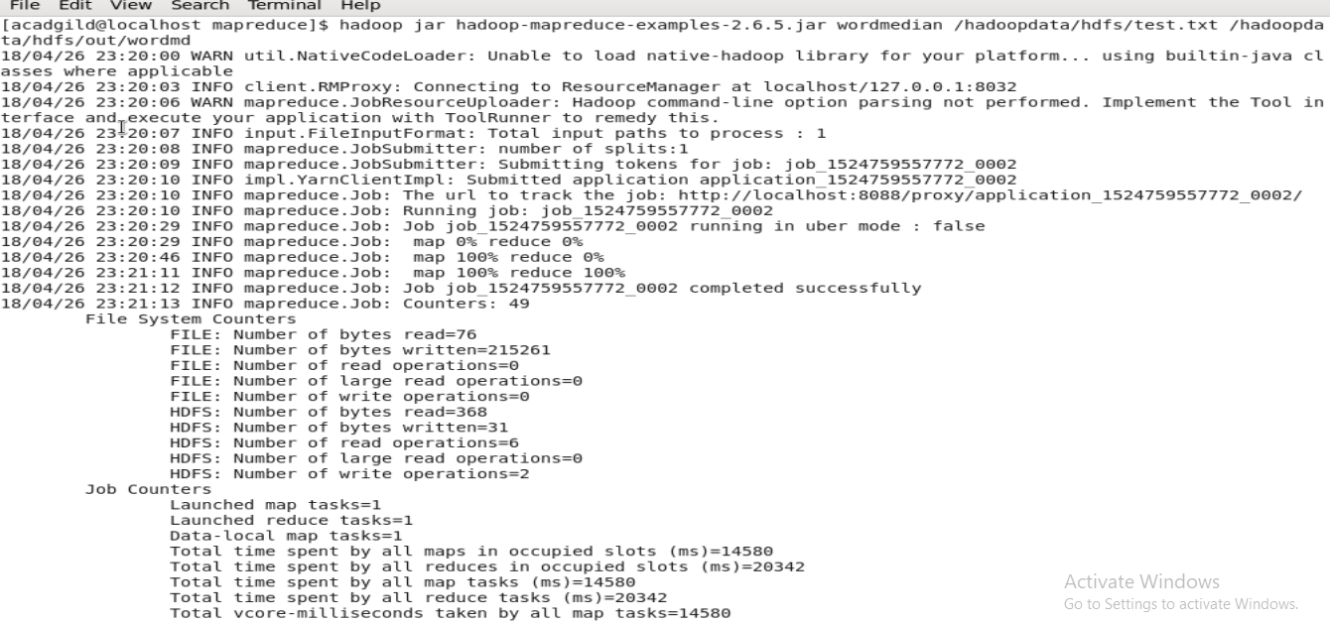

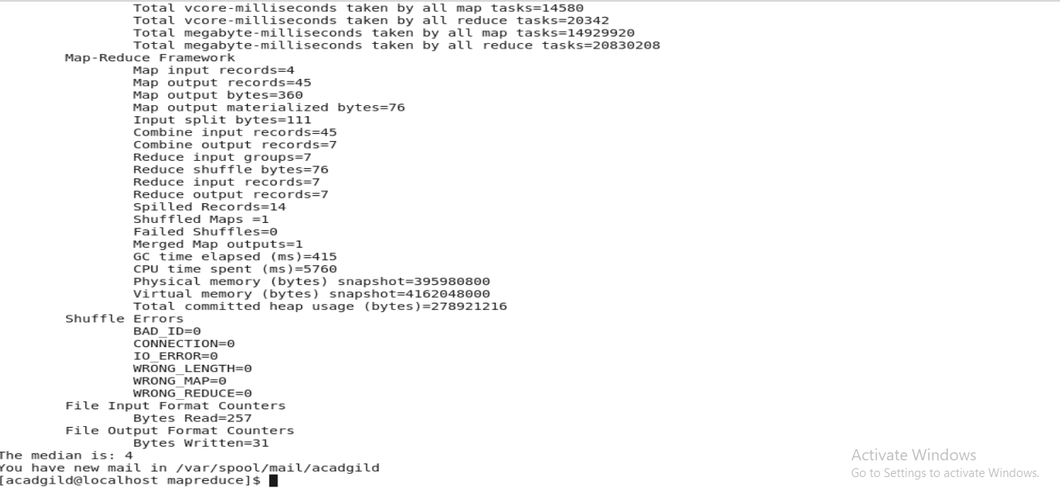

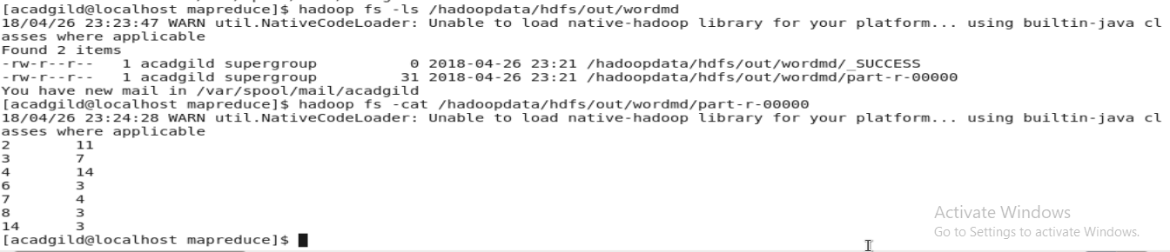

WordMean​

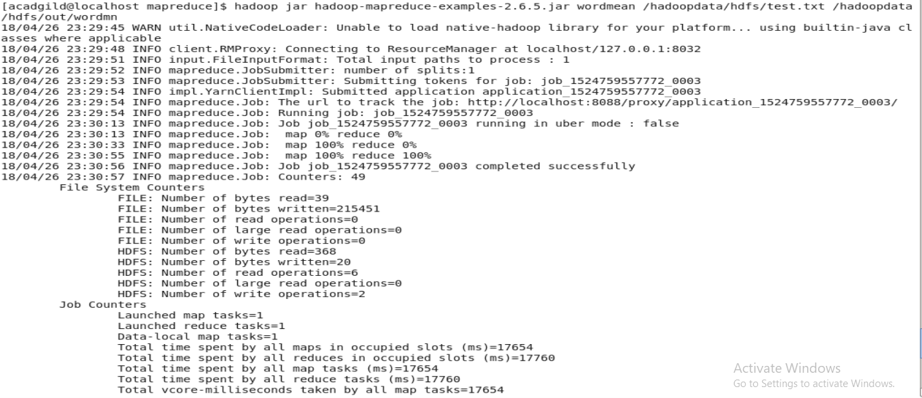

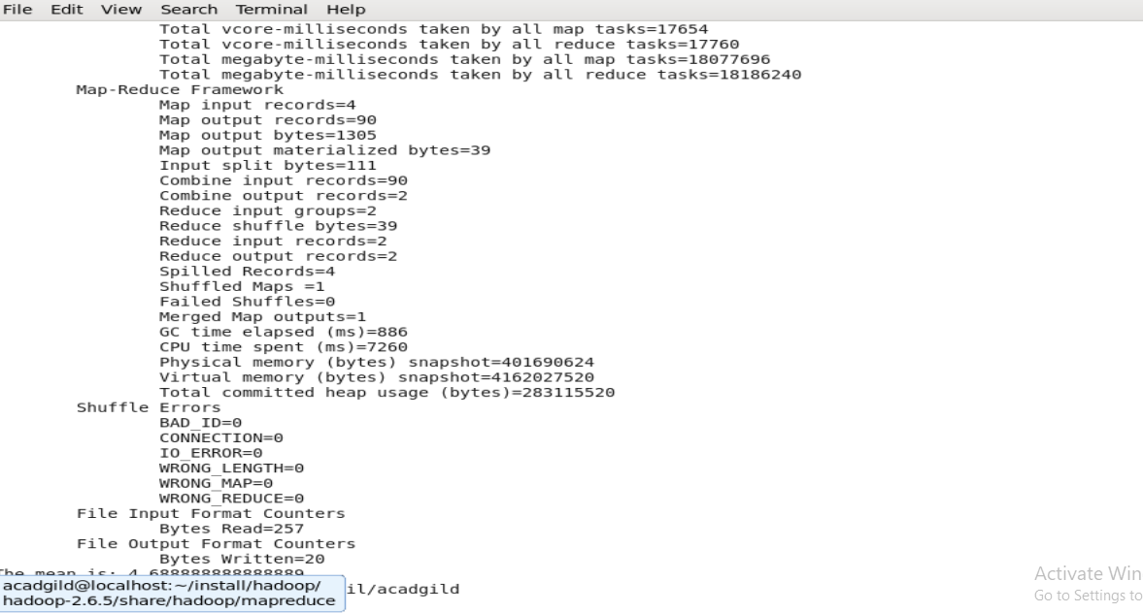

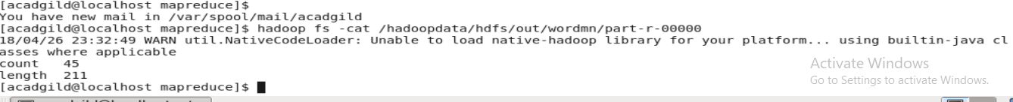

WordStandardDeviation

